**ICA Classification Results**

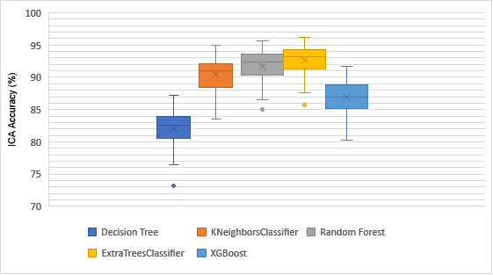

**Figure:** Box Plot of Accuracy Comparison of Different Machine Learning Algorithms with ICA as Dimensionality Reduction

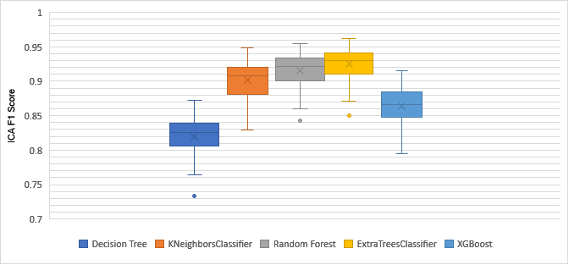

**Figure:** Box Plot of F1 Score Comparison of Different Machine Learning Algorithms with ICA as Dimensionality Reduction.

**PCA Classification Results**

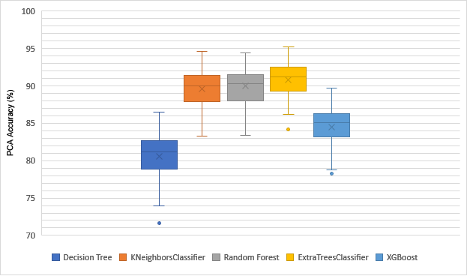

**Figure:** Box Plot of Accuracy Comparison of Different Machine Learning Algorithms with PCA as Dimensionality Reduction

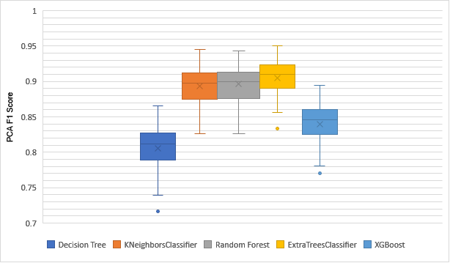

**Figure:** Box Plot of F1 Score Comparison of Different Machine Learning Algorithms with PCA as Dimensionality Reduction.

**TSNE Classification Results**

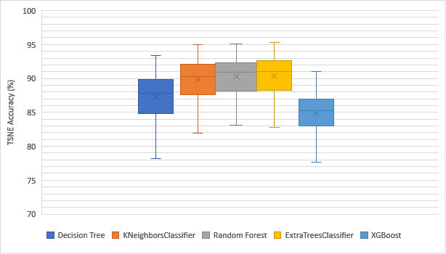

**Figure:** Box Plot of Accuracy Comparison of Different Machine Learning Algorithms with TSNE as Dimensionality Reduction

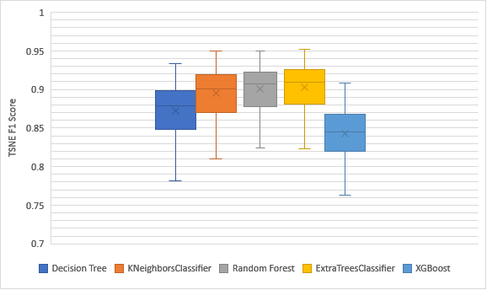

**Figure:** Box Plot of F1 Score Comparison of Different Machine Learning Algorithms with TSNE as Dimensionality Reduction.

**Machine Learning Classification Results**

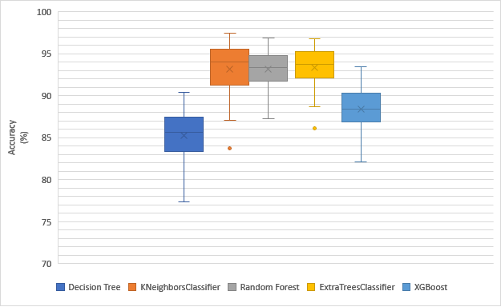

**Figure:** Box Plot of Classification Accuracy Comparison of Different Machine Learning Algorithms

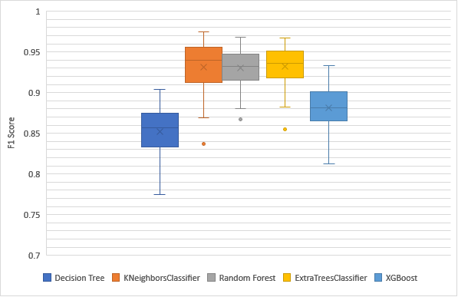

**Figure:** Box Plot of F1 Score Comparison of Different Machine Learning Algorithms

**Deep Learning Classification Results**

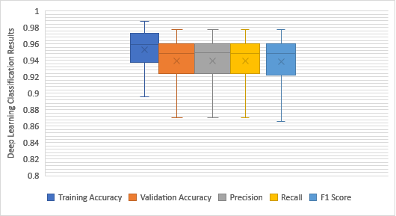

**Figure**: Box Plot of Deep Learning Classification Results of All 27 Subject of Dataset 1.